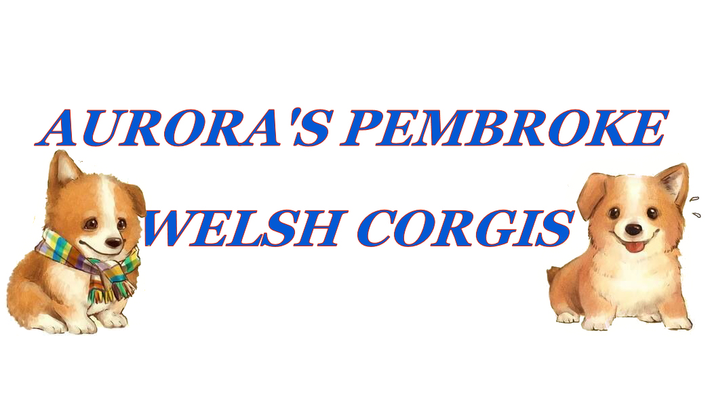

PURCHASE AGREEMENT CONTRACT

For: ________________________

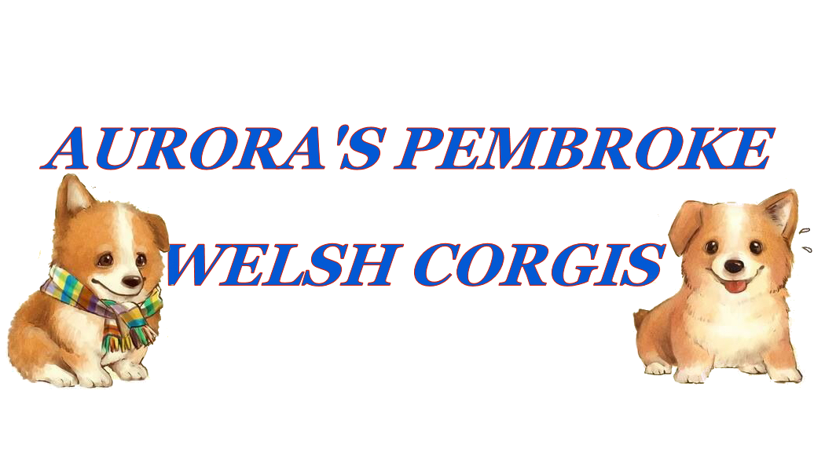

This agreement is made, and hereby entered into, on this ______ day of_____________, 20__ by and between Julia Schubert or Fred Schubert (hereafter referred to as “Seller”), and

_____________________________________________________________(hereafter referred to as “Buyer”), for the purpose of setting forth the terms and conditions of the purchase by the Buyer of a purebred Pembroke Welsh Corgi.

Said Corgi shall be from the breeding of:

Sire_ Dam:

Puppy call name:___________________ Registration: Full/Limited

DM Status: __________________
Microchip#_______________________
Buyer: _________________________________________ | Date: _____________
Address: _______________________________________ | City: ______________

State: ________________________Zip:________________

Home Phone: ____________________________ Cell Phone _____________________

E-Mail Address: ________________________________________________

Sex of Puppy: Male/Female

Purchase Price: _________________________

Congratulations on your new puppy! The parents of your puppy are both amazing family companions! This litter was bred with the intent to better the Corgi breed and meet or exceed the breed standard in all ways. Should you, the buyer, at any time prior to taking possession of your puppy should change your mind it shall be understood that any deposit paid shall remain on record to be used towards a purchase at any later date. Though non -refundable, any deposit and or payment shall remain valid indefinitely. As breeders, it is our hope that you will take exceptional care of this puppy throughout its entire life. This means providing socialization, medical, proper nutritional, physical needs as necessary, treating your dog as part of your family, and giving it lots of love for the remainder of
its life. If for any reason you are unable to keep this puppy please contact us first. Our puppies are always to be returned to us if they can not be kept. Remember that environment and how it raised has tremendous impact on how the dog will turn out.

The above referenced dog/puppy is being sold to the buyer(s) in good health and has been thoroughly examined by a licensed veterinarian with proper shots and worming. Seller certifies that said puppy is in good health to the best of Seller’s knowledge. Buyer is required to take the puppy within 72 hours after taking possession to a veterinarian for a health checkup. If Buyer fails to take puppy to the vet within 72 hours of possession, all health guarantees are void. If upon examination the veterinarian finds that said puppy is not in good health, and is unable to be medically treated, the Buyer must notify the Seller within 24 hours in writing. Buyer shall return the puppy to the Seller with all of the veterinarian documentation and registration paperwork at Buyer’s expense. Seller shall replace said puppy with another puppy of equal value as soon as one is available. Buyer is responsible for all shipping costs. Seller has no obligation to reimburse Buyer for any costs incurred, i.e., medical, shipping, crate, etc. Seller does not guarantee against conditions brought on by stress or environmental changes that we can not control once the puppy leaves our care; therefore our guarantee does not cover; hypoglycemia, parasites, giardia, viral or bacterial infections after the puppy leaves our care. We do not guarantee against parvo, coccidiosis, distemper or corona virus because these are highly contagious disease that can be contracted immediately upon leaving our property. Seller makes no guarantee as to puppy’s fertility or breeding abilities. The Buyer agrees that if the puppy is to be shipped, Buyer has 12 hours after the time of pickup to notify Seller of the puppy’s arrival. If Buyer does not notify Seller within 12 hours after pickup of the puppy, all guarantees of this contract are void. Buyer understands that any shots given before the vaccination schedule recommends voids the contract guarantees. Over vaccination can be very dangerous to young puppies. Please remember to take the vaccination schedule that you are provided to your vet, and do not allow them to give extra vaccinations that are not due! Buyer also understands that the best way to determine if additional shots are required is to do a blood titer on the puppy at the vet. This will show fully the puppy's resistance levels and allow vets to better determine if a booster shot is needed at all.

This puppy is guaranteed against genetic defects for 2 years after the date of sale of the puppy. If puppy is found to suffer from a genetic defect by a certified veterinarian, Buyer must notify Seller via certified mail, with written statement, and complete medical records from the veterinarian within 24 hours. Seller has the option to request a second vet opinion before replacement is offered. Buyer understands that the following genetic defects are not considered serious or life threatening and therefore are not covered: umbilical hernia, undescended testicle, low grade heart murmur, underbite, overbite, etc. Buyer understands that replacement option is only valid when health problems are attributed to a hereditary problem and not due to accident, contagious and/or other illness, or environmental conditions. Buyer has the option to return the defective puppy to the Seller, or to keep the puppy at Buyer’s expense. If a replacement puppy is offered to the Buyer, from the first available litter containing a puppy of equal value, it will be offered regardless of Buyer keeping puppy or returning original puppy. Proof must be furnished to the Seller that the defective puppy has been altered against ever being bred, if it is to be kept by the Buyer, before a replacement puppy is offered. Under no circumstances will the purchase price of the defective puppy be returned. Seller has no obligation to reimburse Buyer for any costs incurred, i.e., medical, shipping, crate, etc. This is a replacement guarantee. No monies will be refunded. If a replacement puppy is offered to the Buyer, and Buyer refuses said replacement puppy, then the Buyer agrees that the terms of the replacement guarantee have been met, and no further replacement puppy or compensation will be offered to the Buyer by the Seller. Only one replacement puppy will be offered under these terms. It will be of the same sex and the same or better quality. Buyer understands that a replacement puppy may not be immediately available. Seller has 1 year (12 months) to offer a replacement puppy if Seller deems the situation warrants it. Seller has full discretion on picking a replacement puppy.

The Seller is to be notified should any unusual health problems occur at any time or upon the death of this dog. If this puppy should pass away, an autopsy is required. Breeder is to be notified immediately, and provided with autopsy results and two separate vet statements detailing the cause of the puppy’s death, in order for any replacement to be offered, if the cause of death is covered under the terms of our contract.

The Buyer agrees that any and all transportation costs, to and/or from the Seller’s premises, will be at the cost and sole responsibility of the Buyer.
The Buyer agrees to maintain preventative health care of the puppy including, but not limited to: inoculations, internal as well as external parasites, heart worm preventative medication. If the puppy is not kept current on preventative health care then the terms of the contract regarding any health guarantee, is void. The Buyer agrees to maintain preventative care of the puppy in regards to hip and elbow dysplasia, such as proper nutrition, proper exercise, and preventing stress injuries (ie. Not allowing the puppy to jump from heights taller than itself at the shoulder, no forced exercise such as running, no excessive climbing stair cases, until at least 12 months of age.)

This contract is non- transferable and is only valid when the original two parties are involved., and must be presented to Seller to be valid.

The Buyer agrees that the puppy will NOT be left alone in the backyard or kennel for long period of time. The Buyer agrees that the puppy will reside at the home of the Buyer, and not be chained or “tied out”. This animal is sold with the understanding that it was to go to select homes, be socialized properly, and become a member of the family.

Buyer agrees to release and hold harmless Seller for any and all liability, damages, or injuries, caused either directly or indirectly by Puppy to any person, animal, whether actual or legal, or to any property whether real or

personal. Furthermore, Buyer assumes full liability for any damages or injuries, whether physical or mental, emotional or economic, caused by Puppy, to any person whether actual or legal, or to any property, whether real or personal, after receiving and acknowledging delivery and possession of Puppy.

Buyer agrees to release any and all vet records for any and all vets that care for above puppy, to Seller via fax, phone, or email. By agreement to the contract Buyer agrees to allow all vet records to be sent and discussed with Seller. Buyer agrees that below vet is the vet that will be caring for above puppy, and their full information is required below.

If the above puppy is sold on Limited AKC Registration, then papers will be provided to Buyer only after proof of spay or neuter has been furnished to the Seller, including Microchip number on vet's letterhead. Proof may be faxed, mailed, or emailed to be valid. Papers will be furnished at the time of pickup for puppies placed with AKC Full Registration.

The Buyer agrees to provide Seller with pictures and updates on said dog/puppy at least twice (2 times) yearly. We love to see our babies as they grow up! Please keep us posted on them! Buyer agrees to notify Seller of any change of address, and/or email address so we know where our puppies are!

Only after the full amount of the agreed upon amount is paid, may the puppy be removed from the Seller’s premises. This agreement is made and signed by both parties to insure the well being and protection of this

animal. Buyer’s Violation of the contract will constitute Buyer's unconditional surrender of the purchased dog any/all offspring and all registration documents at no cost to the Seller. Buyer is responsible for all shipping/transportation costs to return this puppy to Seller. Seller has full rights of repossession if this contractual agreement is breached by Buyer.

Buyer agrees to release any and all vet records for any and all vets that care for above puppy, to Seller via fax, phone, or email. By agreement to the contract Buyer agrees to allow all vet records to be sent and discussed with Seller. Buyer agrees that below vet is the vet that will be caring for above puppy, and their full information is required below.

This contract shall be deemed a legal and binding agreement between Seller and Buyer and is under the jurisdiction of the State of Kentucky in the county of McCracken. It is further agreed that should any dispute/arbitration between Seller and Buyer regarding said puppy/dog occur that the legal venue shall be the County of McCracken, Kentucky
I/We the undersigned have read the contract, consisting of 3 pages and do agree to the terms and conditions stated within the contract. The written terms of this contract constitute the entire agreement between the two parties. No verbal statements, promises, or any kind of other written documents shall have effect upon this contractual agreement. Should it be necessary to enforce any part of this contract, or should legal action be taken by either party, any and all attorney fees, court costs, and travel expenses shall be the sole responsibility of the purchaser. I understand that no monies will be refunded at any time. Electronic Signature stands as legal signature in this agreement.

DATE: ___________SELLER:_______________________BUYER:___________________________

Vet Information: Name:____________________________________

Phone Number:____________________________ City/State:__________________________________

Additional Comments:
___________________________________________________________________________________

